Frolic Boonies African Wildlife Camp

Meet the Fab 5 with us !

Lion, Cheetha, Zebra, Giraffe and Hippo
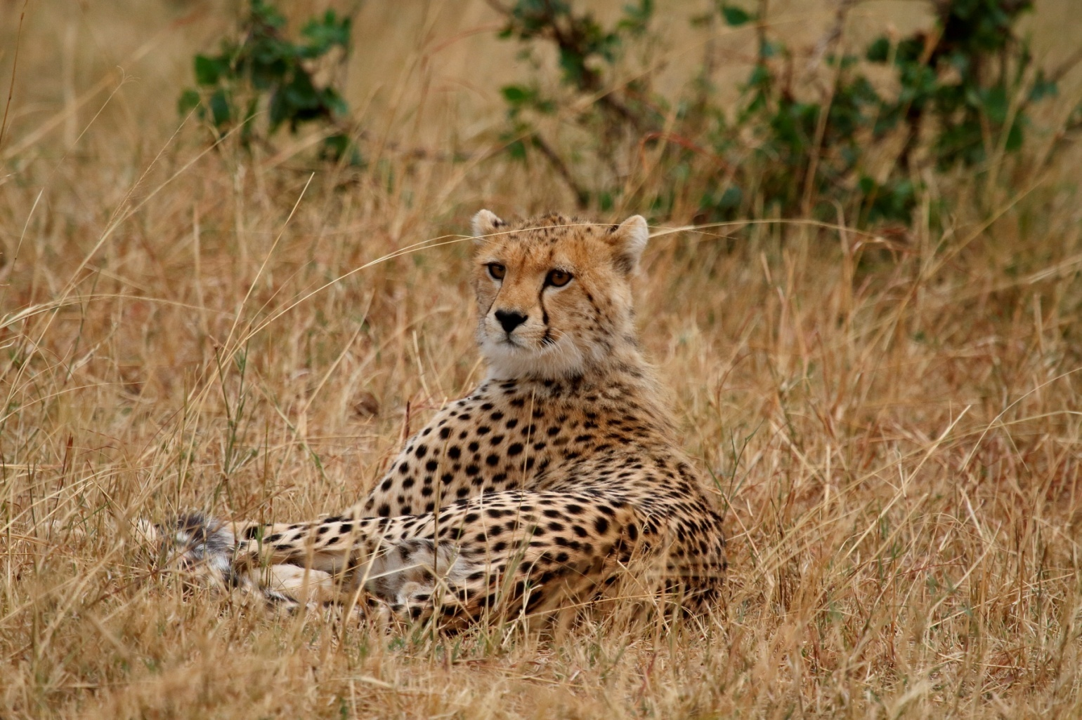

7 Days / 6 Nights camp at Kenya Covering
- Masai Mara Game Reserve 4 Nights
- Nairobi 2 Nights

Day 1 - Oct 8th 2016 Departure Bangalore / Arrival Nairobi

Start from Bangalore to Nairobi by flight

Welcome!

Visit the Giraffe Rescue centre and feed the giraffes. You also get an opportunity to get a selfie with a giraffe.

Night halt at Nairobi - in Hotel Kenya Comfort or Similar very close to the top super markets and city centre

Giraffe Rescue Centre

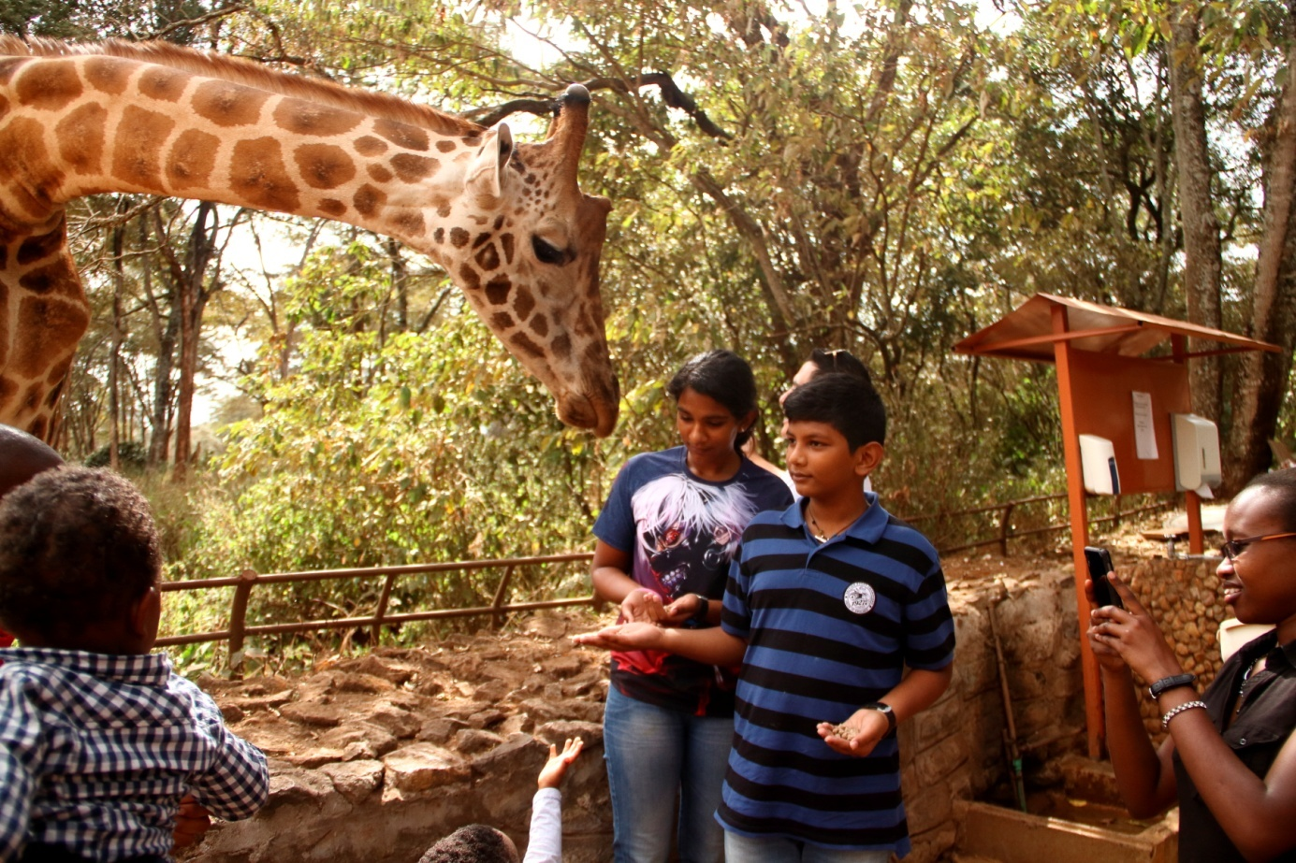

Great Rift Valley
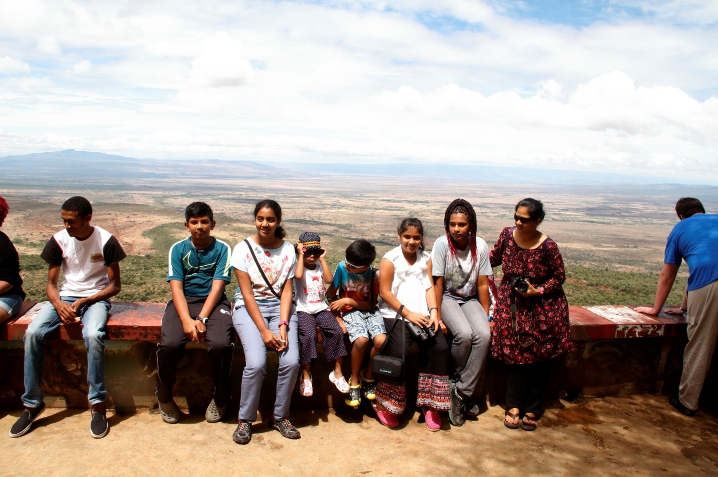

Day 2 – Oct 9th: Nairobi Hotel – Masai Mara
Early morning pick up from Nairobi Hotel, then drive to drive along the Great Rift Valley, passing by the extinct volcano of Mount Longonot en route to Masai Mara Game Reserve with game en route to the camp for check in as well for lunch. Afternoon game viewing in this fascinating wildlife paradise with a chance to view giraffes, elephants, monkeys, leopards, lions, gazelles and different bird's species. Dinner and Overnight at Keekorok Lodge, Masai Mara or similar (Breakfast, Lunch & Dinner)
The Wild Beast Migration
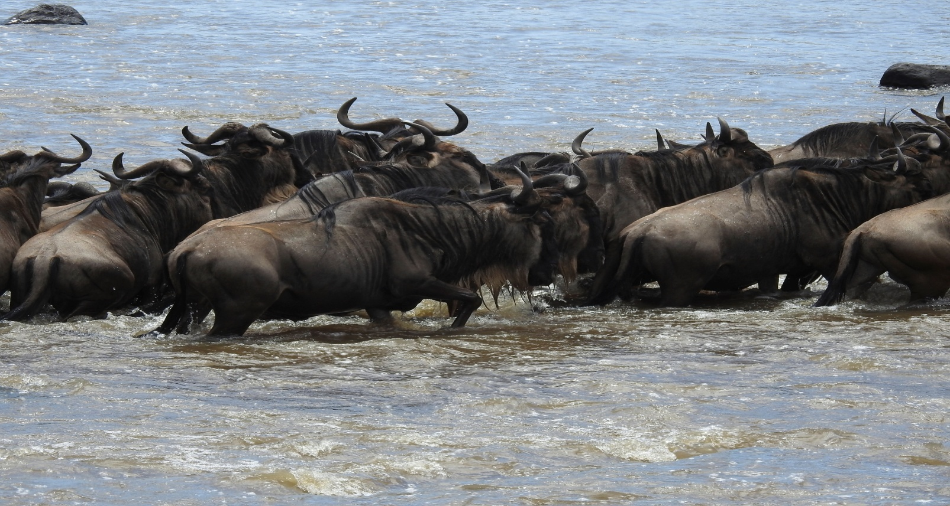
Elephant Herd
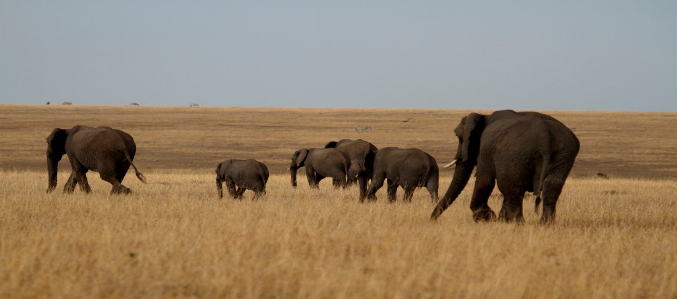
Daily Game Drives on 4 Wheel Drive Jeeps
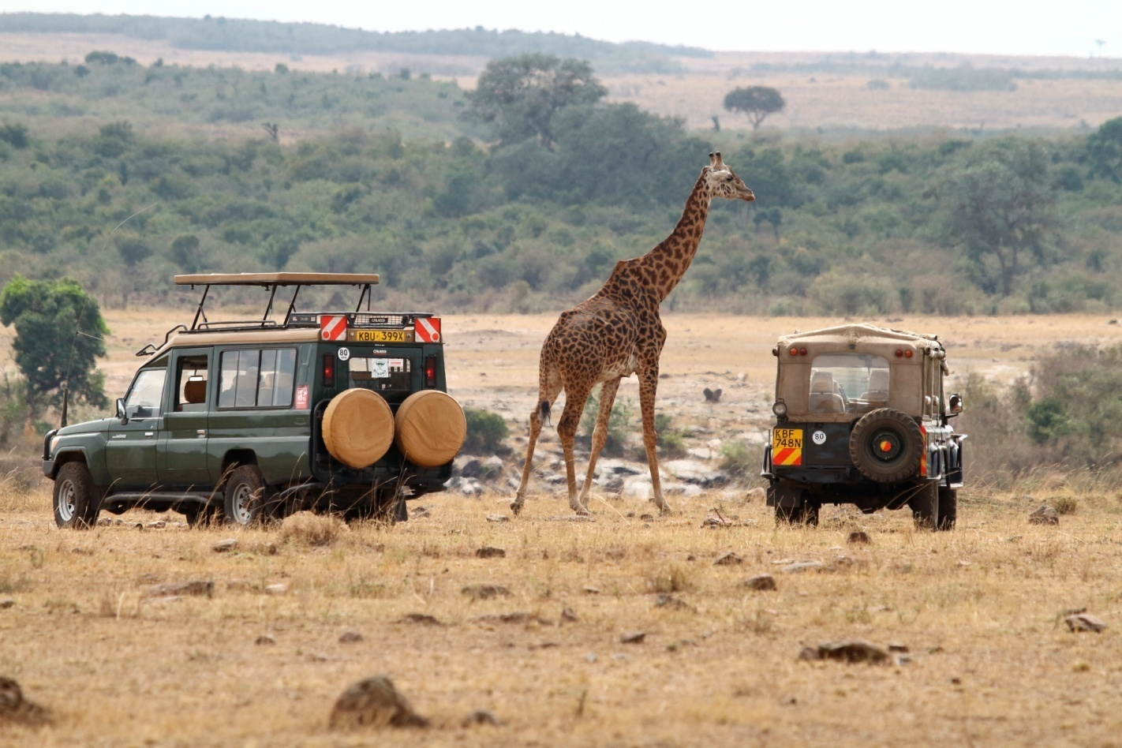
Game Viewing Deck at the Resort
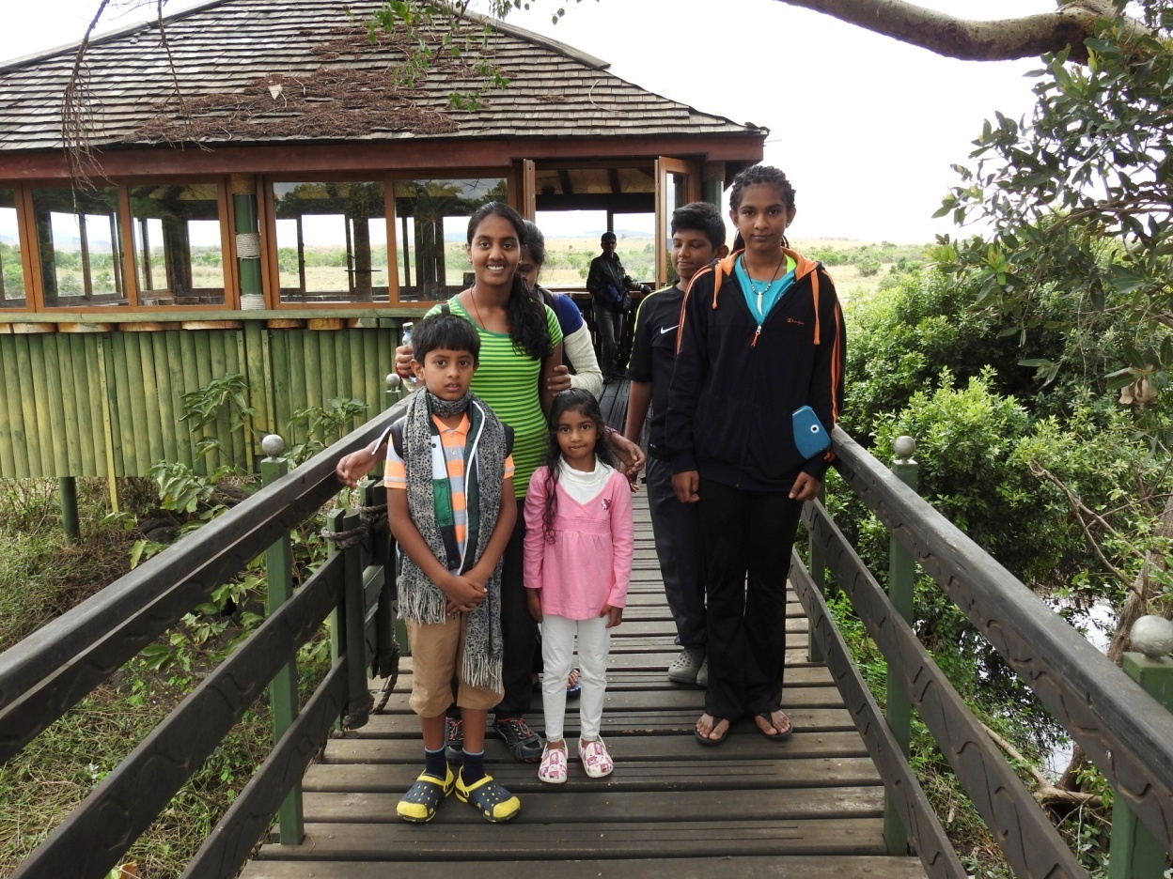
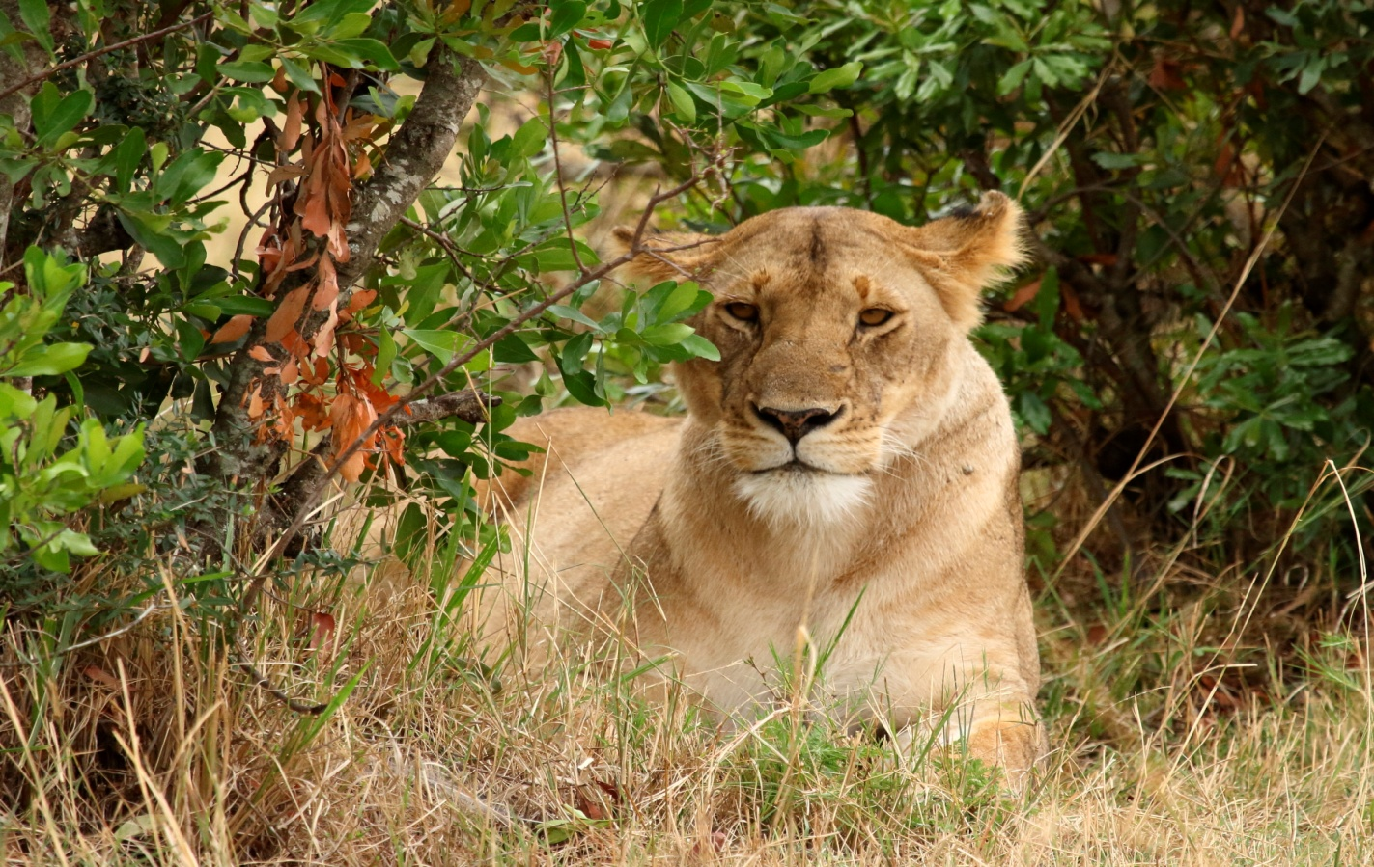
Day 3, 4, 5 – Oct 10th, Oct 11th Oct 12th - Game drives through the day looking for different mammals and bird species in Mara / Keekorok zone. (Breakfast, Lunch & Dinner). On one of the days visit the Masai Village and interact with the Masai tribes. Also shop for some products made by the tribes.
Masai Tribal Interaction
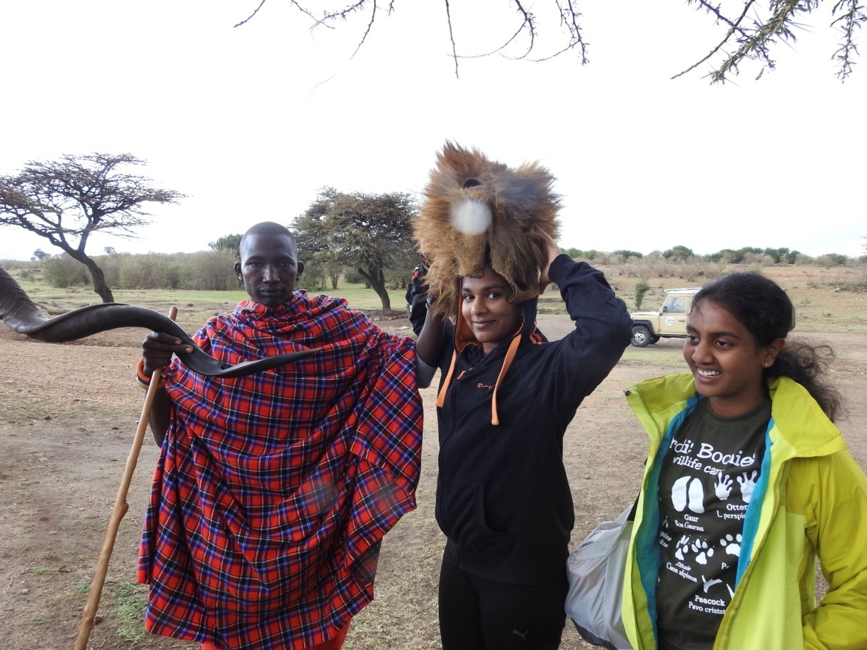
Experience Bartering System with the Masai Tribes

Day 6 – Oct 13th: Masai Mara - Nairobi
Early morning game drive, After Breakfast, drive to Nairobi, over night at Nairobi
Dinner and overnight at Nairobi Hotel, (Breakfast, Lunch & Dinner)

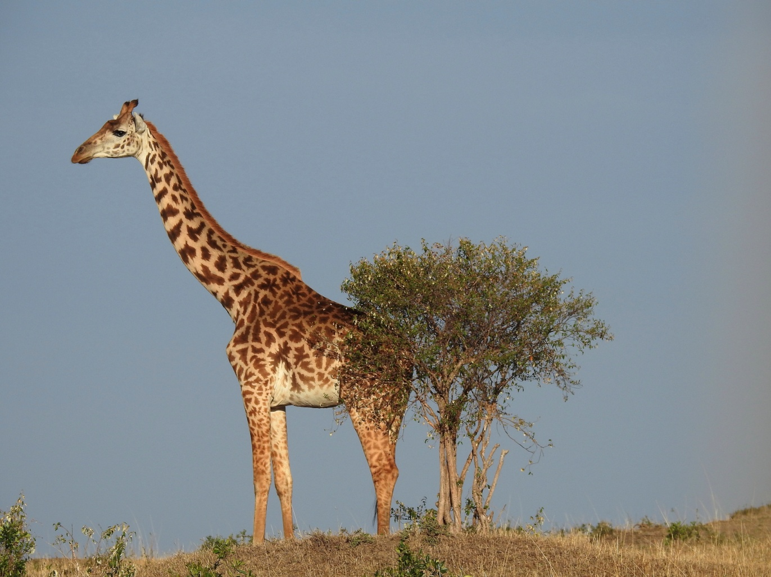

Day 6 – Oct 13th: Lake Nakuru National park - Nairobi
After breakfast leave to Nakuru for a game drive to see black and white hippos, flamingos, Rothschild giraffes. On the floor of the Great Rift Valley, surrounded by wooded and bushy grassland, lies the beautiful Lake Nakuru National Park. Visitors can enjoy the wide ecological diversity and varied habitats that range from Lake Nakuru itself to the surrounding escarpment and picturesque ridges. Lake Nakuru National Park is ideal for bird watching, picnic and game drives.

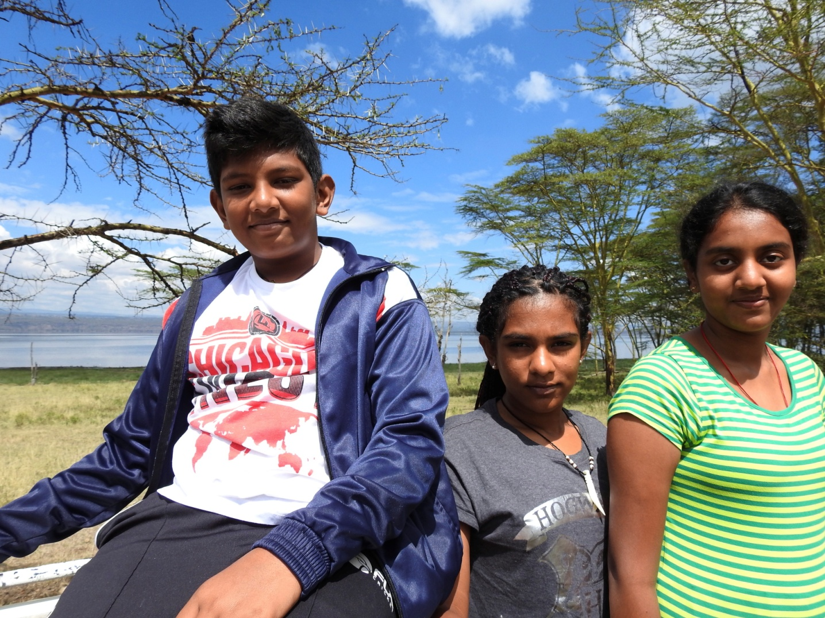

Day 7 – Oct 14th: Nairobi to Bangalore by flight

Experience the Awesomeness of Africa

SEE YOU ON THE SAFARI .......
TOTAL COST PER PERSON Rs. 165,000.00

Payment Details (Installment Option)
- Dec 2015: Rs. 30000
- Jan 2016: Rs. 15000
- Feb 2016: Rs. 15000
- Mar 2016: Rs. 15000
- Apr 2016: Rs. 15000
- May 2016: Rs. 15000
- Jun 2016: Rs. 15000
- Jul 2016: Rs. 15000
- Aug 2016: Rs. 15000
- Sep 2016: Rs. 15000

Includes
- Cost of your round trip economy class air ticket with airline taxes valid for the duration of the tour. (Calculated at 1st Dec 2015 rates) Booking on later dates will incur fare difference to be paid
- Accommodation in the hotels/ camps mentioned or similar on triple sharing basis
- All meals as per itinerary
- Park entries at Masai Mara, Nakuru
- Boat ride Naivisha lake
- All Game drives
- 4x4 safari van with pop roof for game drive
- Transport to and back to airport
- Driver cum guide charges

Excludes:
- Any increase in the Airfare / Airline Taxes charged by the airlines on your air ticket. (Calculated at 1st March 2016 rates)
- Service Tax
- Visa & Airport taxes (Estimated 55 USD)
- Cost of Overseas Travel Insurance policy valid for the tour. (Passengers above 70 years of age will have to pay the actual difference of the insurance premium along with the medical reports).
- Processing Fees
- Cost of extension of the validity of your air ticket.
- Tips
- Sleeping bags
- Rain jackets, hand gloves
- Personal needs, Porterage, laundry, wines, mineral water, telephone charges, suggested excursions and all items of personal nature and also food and drinks not forming part of the group menus.
- Anything not specifically mentioned in ‘What your Tour Price includes’
Terms:
- Passport should be valid for at least 6 months from the departure date
- Flight Ticket is non refundable
- Cancellation before 90 days will be eligible for full refund, less flight ticket unless mentioned otherwise.
- Cancellation between 90 to 45 days before the commencement of the camp- Deduction will be 10% of the camp fee less flight ticket.
- Cancellation between 44 to 31 days before the commencement of the camp– Deduction will be 20% of the camp fee less flight ticket.
- Cancellation between 30 to 25 days before the commencement of the camp – Deduction will be 30% of the camp fee less flight ticket.
- Cancellation between 24 to 16 days before the commencement of the camp – Deduction will be 50% of the camp fee less flight ticket.
- Cancellation within 15 days before the commencement of the camp – No refund will be given less flight ticket.
For more details Call on – 9448476888 or drop us a mail – camp@frolicboonies.com

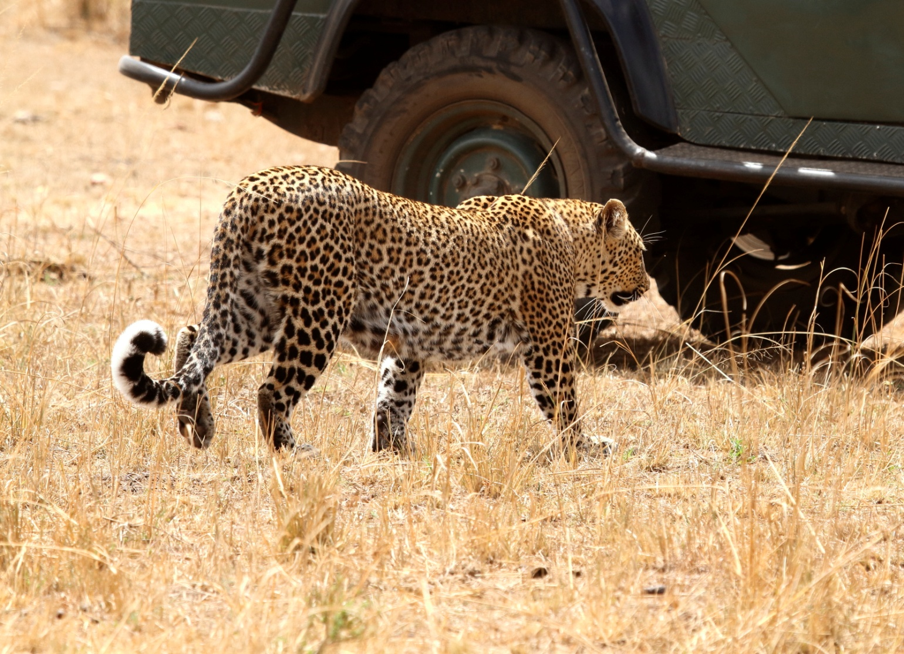

We Kids Had Tons of Fun Exploring the African Wildlife Now Its your Turn
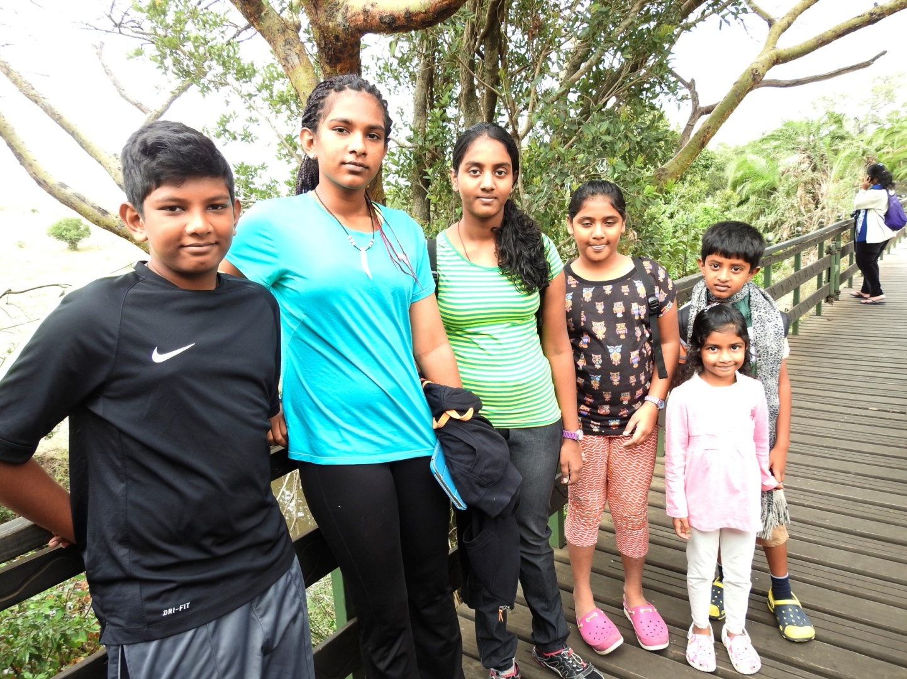

Waiting for You!
